FROM THE DESK OF THE PRESIDENT

NEON GROUP OF COMPANIES

Dear Friends,

Neon is a trusted brand in the world of sugar, oil and gas, printing, food processing, steel, power generation and many other industries, defined by the values, character, and integrity of its people. Neon is an export house based in Mumbai (India). Our core strength is to supply the best quality products to all our customers which are based in the east and west of Africa and other parts of the world.

Our works adhere to the highest quality standards like BIS, JIS, ASME, IS, EN 13445 etc. including CE certification. We are proud to mention that in a world full of challenges we have been consistent in our growth. We have also appreciated the contribution of women's participation in our journey and continue to do so. Our company is verified by GHG (Greenhouse gas) emission India for keeping in control the emission of gases.

Our philosophy is to invest in relationships and therefore we have friends in many industries who have trusted us. We look forward to have a long-term business association and friendship.

With warm Regards,

Sumit Shah

(President)

SERVICE DIVISION

ON-SITE DYNAMIC BALANCING

On-site dynamic balancing services for various rotating equipment (Including but not limited to blowers, fans, centrifugal machines, machine spindles, crushers, crankshafts, etc)

We are providing special on-site dynamic balancing services for any rotating parts or assemblies at your site by our most experienced and skilled service engineers. At Neon, we have a team of skilled experts and engineers who will come to your doorstep to provide balancing services that will address all the problems of the machines. Neon’s creativity is supported by the most advanced portable machines available, right from the diagnosis of equipment to the final balanced product. All these activities are taken care of by our team at client's doorstep.

**On-site dynamic balancing End users :**

cement, steel, distillery, chocolate, coffee, paper, power plant, food processing industries etc.

PROCEDURE FOR DYNAMIC BALANCING

1. Vibrations caused by the machine are checked with the help of a vibration analyzer and necessary readings are taken for speed, frequency etc.
2. Noise analysis is carried out for the machine, checking the noise generation due to unbalance.
3. After the analysis procedure, step-by-step weight is added to the machine, either with the help of nut and bolt or welding material is added to the machine.
4. Above procedure is repeated till noise and vibrations generated from the machine lowers and ultimately stop.
5. Before and after readings of the vibration analyzer are noted to understand the amount of unbalance removed from the machine.

ADVANTAGES OF ON-SITE DYNAMIC BALANCING

* This service provides several incentives to our clients allowing them to reduce the cost of shipment, transit time, material handling cost.
* There will be fewer breakdowns as onsite dynamic balancing is performed and will reduce production loss and save production cost.
* It saves dismantling and assembly time as the equipment is diagnosed in assembled condition.
* It will save electricity power from drive motors of equipment reducing operational costs.
* It eliminates transportation and handling cost.
* It reduces noise and vibrations of the equipment resulting smooth operation of equipment.
* Also, the quality of the work can be monitored at site.

PRODUCT RANGE

**PACKING AND JOINTING MATERIALS**

|  |  |
| --- | --- |
| **Mechanical Seals** |  |
| * + Multi spring seal   + Single coil spring seal   + Rubber bellow seal   + Teflon bellow seal   + Metal bellow seal   + Cartridge seal   + Double cartridge seal   + Dry seals for reactors   + Multi-segment carbon seal   + Spiral gaskets   + Split Seal   + Springless seal   + Balanced wave spring seal   + Rotary Unions |

|  |  |
| --- | --- |
| **Gasket and Non-Metallic seals** | |
| Non-Metallic Gasket |  |
| Semi-Metallic Gasket |
| Metallic Gaskets |
| Gland packing |
| O-rings  Pneumatic seals |
| Rotary Shaft seals |

CATERPILLAR PRODUCTS AND SPARES

|  |  |
| --- | --- |
| 1. Diesel generator set spares for Marine industry | |
| * Oil level Sensor * Oil seals & Gaskets * Air/Fuel/Oil Filter * Starter Motor * Voltage Regulator * Nut-Bolts * Engine Overhauling kit * SS round shape Marine Bearing * Generator rotor & Fan * Generator silencer * Thrust Washer * Crankshaft Kit * Connecting rod * Rocker shaft assembly and Arm set * Piston Ring * Injector pipe * Water pump * Impeller kit for water pump * Alternator and its belts * Oil pressure gauges  1. Dozer and Excavators spares  * Track chain * Track shoe * Track roller * Hydraulic double pump and its parts * Engine spare parts * Bucket link rod * Relief overflow valve and its spares * Tooth bucket spare parts * Crawler * Mechanical spares |  |

REENGINEERING AND RETROFITTING OF PRODUCTS

NEON can also help you in procuring machinery/parts, which are out of the manufacturing range of original manufacturer, from India based on available drawings or samples. We would like to inform you that we are in a position to restore/rebuild your existing equipment without compromising its performance. In this process, our technical team visits the factory site and there experts study the equipment and its working condition, identifying the areas of trouble.

The process is followed while undertaking the retro fittings of the parts:

1. Our team from India will visit your factory/site.
2. Design and drawings will be taken on site.
3. Experts study of the working condition.
4. Obtaining MOC and the chemical composition required for manufacturing of the part.

We mention below few examples of our services rendered and machinery supplied to Sugar factories:

1. We have successfully manufactured, supplied and commissioned 2 Nos. of complete Mill Turbine Rotor Shafts with Blades of 1200 KW Turbines based on old Turbine Rotor and on-site actual dimensions taken by our Technical team.

2. We have also supplied Centrifuge Baskets, screens and other spares for SC 1350 KT - 30° Centrifugal Machines after preparation of as built drawings and understanding exact requirements of Sugar factory.

3. We have prepared manufacturing drawings of Pump spares like body, impeller, shaft, mechanical Seal etc. of various brands of Pumps for one of the Sugar Mills and thereafter we have also supplied them required Pump Spares to suit their existing Pump sets.

4. We have successfully manufactured and supplied Oil Filters, Mechanical Seals, Mill Roller Grooving Tools, Rubber and plastic moulded parts, special type of couplings etc. exactly as per client's samples and matching not only the material of construction but also the quality and dimensions.

Thus, we can take up the challenge of manufacturing and supplying of any part of machinery and spares with the help of expertise of our technical team and/or your samples to substitute various European Make/Brands.

ELECTRICAL MOTORS WITH CONTROLS AND SPEED REDUCERS

|  |  |  |
| --- | --- | --- |
| * Motors | | |
| * + Slip ring induction motor   + Squirrel cage induction motor   + Geared motors   + DC series motor & shunt motor   + Three-phase motor   + Single-phase motor   + Synchronous motor   + Water-cooled motor   + Flameproof motor * Controls, VFDs and transformers   + Electrical switches   + Fuses   + Circuit breakers   + Variable frequency drives (VFDs)   + Transformers |  | |
| BEARINGS | | |
| * Deep-Groove Ball Bearings * Roller Bearings * Spherical Roller Bearings * Cylindrical Roller Bearings * Tapered Roller Bearings * Needle Roller Bearings * Fluid Bearing * Self-Aligning Ball Bearings * Thrust Ball Bearings * All types of bearings of FAG and NTN make |  | | |
| GAUGES | | | |
| * + Bourdon Tube Pressure Gauge   + Diaphragm Pressure Gauge   + Capsule Pressure Gauge   + Differential Pressure Gauge   + Hydraulic Pressure Gauge | |  | |

Custom based manufacturing products

**We are in a position to manufacture and supply the below items on custom-based requirements. Also, we would like to inform you that we are in a position to study your samples and can provide you the exact product.**

|  |  |
| --- | --- |
| * Air filters * Oil Filters * Reciprocating Compressor Filters * Hydraulic filters * Fluid Filters * Customized Filter as per requirements * Rubber items and material * Workshop machineries * Gaskets * Electrical control panel * Customized grooved rubber belts * Flexible hoses * Washer * Perforated Screens/sheets(Range: 50 to 740 Micron) * Rubber sheets(Abrasion resistant, neoprene, Hypalon, silicon, NR electrical insulation) |  |

|  |  |
| --- | --- |
| COUPLING, PULLEYS AND CHAINS | |
| * Coupling   + Full Geared coupling   + Half Geared coupling   + Resilient coupling   + Fluid coupling   + Rigid coupling   + Disc coupling   + Tyre coupling   + Chain coupling   + HRC coupling   + Jaw coupling   + Brake drum type coupling * Pulley   + A, B, C & Z Groove pulley   + Timing pulley   + High torque pulley   + Variable speed pulley   + Wire rope pulley * Chains   + Standard roller chain   + Double pitch chain   + Standard roller chain with attachments   + Cable drag chain   + Single & multiple strand roller chain   + Wire ropes and cables |  |

|  |  |
| --- | --- |
| BELT AND OTHER CONVEYORS WITH ACCESSORIES | |
| * Conveyor belts * Chevron belts * HR Grade belts * Food grade quality conveyor rubber belts * V-belts * Nylon belts * Canvas belts |  |

|  |  |
| --- | --- |
| PUMPS AND PUMP SPARES | |
| * Centrifugal process pumps * Air compressor pumps * Submersible pumps * Diaphragm pumps * Progressive Cavity pumps * Dosing pumps * Boiler feed pumps * Injection water and spray water pumps * Magma and molasses pumps * Screw pumps   Gear pumps |  |

INSULATION AND LAGGING MATERIAL

* Rockwool Slabs
* Rockwool LRB mattresses
* Rockwool Slab
* Fiberglass Insulation
* Mineral Wool
* Polyurethane Foam
* High Alumina Castable
* Castable refractories
* Insulating Fire Bricks
* Calcium Silicate Blocks
* Ceramic Fiber Blanket
* Nitrile rubber insulation

SPEED REDUCERS AND SPARES

* Cooling tower gearboxes
* Power transmissions
* Shaft mounted gearboxes
* Right angle gearboxes
* Gearbox housings
* Hardened & ground gearbox
* Helical gearboxes
* Planetary gearbox
* Single reduction
* Double reduction
* Triple reduction
* Quadruple reduction
* Worm gearbox

RUBBER ITEMS

* Rubber Coupling bush
* Rubber Valve sheets
* Rubber profiles
* Rubber gasket
* EPDM rubber gasket
* Nitrile rubber gasket
* O-rings
* Rubber Saddle and skids
* Rubber Valve lining
* Rubber sheets
* Customized grooved rubber sheets
* Industrial molded rubber
* Rubber Wall sheets
* Rubber Hose pipes
* Rubber Canvas belt
* HR grade conveyor belt

JACKS

The jack capacity range is 1 to 150 ton.

* Bottle jack
* Hydraulic jack
* Single acting flat jack
* Single acting ran jack
* Scissor jack
* Pneumatic jack

|  |  |
| --- | --- |
| WORKSHOP MACHINERY | |
| * + Lathe Machines   + Drilling   + Milling Machine   + Grinding Machines   + Shaping Machine   + Tapping   + Boring   + Slotting Machine   + Gear Hobbing Machine   + Threading Machine   + Wood Working Machine   + Special Purpose Machine   + Cutting/Shearing Machine   + Hydraulic Press Brake Machine   + Bending Machine   + Laser Machines   + Flat Bed CNC Lathe   + Re-Sharpening Machine   + CNC horizontal boring & milling machine   + CNC milling machine   + CNC heavy duty lathe machine |  |

**Note: We are in position to supply customized Heavy duty workshop machinery as per your technical requirements.**

WELDING AND CUTTING MACHINES

* Arc Welding Machines
* Tig Welding Machine
* Mig Welding Machines
* Plasma Cutting Machine

|  |  |
| --- | --- |
| ELECTRICAL CONTROL PANELS, SWITCH GEAR ITEMS AND ELECTRICAL HARDWARE | |
| * Electrical Control Panels * Switch gears and its spare parts like relays, current or potential transformers, control panels, and more * Electrical Hardware   + PVC Conduit Pipes & Fittings   + Casing Capping & Fittings   + Electrical Switches   + Wires & Cables   + Boxes & Enclosures   + Distribution Switchgear   + Controllers   + Human machine interface   + Batteries & Chargers   + Connector   + Displays & Optoelectronics | |  | |

STEEL MATERIAL

* Carbon steel and SS plates
* Angles
* Beams
* Channels
* Copper and copper alloy rounds and flats
* Pipes and tubes
* Perforated sheet
* Aluminium plates, chequered plates, round bars, etc

VALVES AND FITTINGS

* Valves
  + Check valve
  + Control valve
  + Globe valve
  + Butterfly valve
  + Gate valve
  + Diaphragm valve
  + Ball valve
  + Needle valve
  + Pinch valve
  + Air valve
  + Forged valve
  + Safety valve
  + Gun metal valve
  + Swing-type non-return valve
  + PP valve
  + Sluice valve
  + Pneumatic valve
  + Solenoid valve
* Fittings
  + Cross and Elbow Fittings
  + Bushing and Union Fittings
  + Flanges
  + Cap, Plug and Nipple Fittings

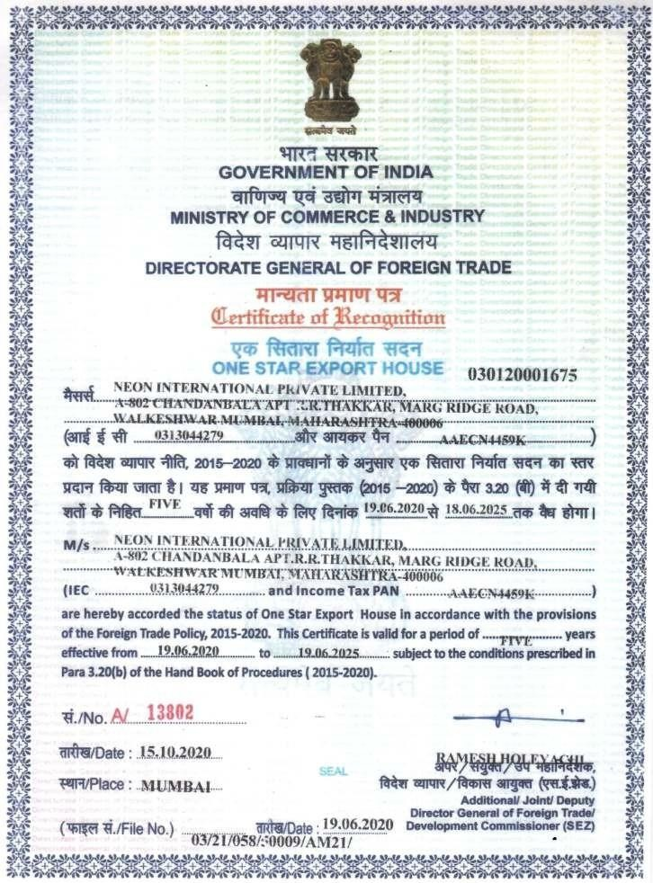

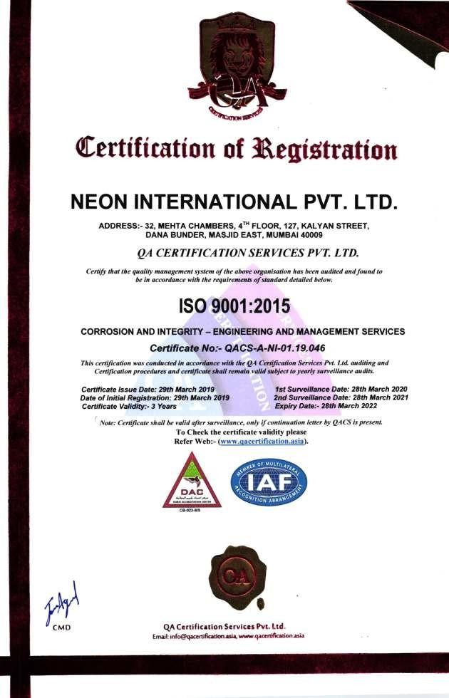



Neon International Pvt. Ltd.

32, Mehta chambers, 4th floor, 127 Kalyan Street, Masjid (East), Mumbai-400 009, India.

Website:

Telephone: + 91 226132 4500 – 4598.

Email: [neon@natexports.net](mailto:neon@natexports.net)

WhatsApp: